References & Research
https://files01.core.ac.uk/download/pdf/338813565.pdf
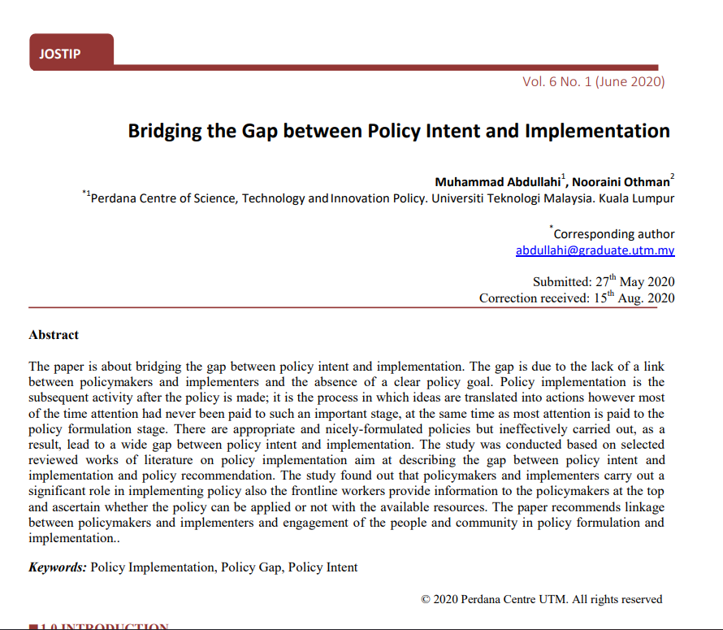

https://www.researchgate.net/publication/399108414_PREDICTIVE_COMPLIANCE_AUTOMATION_USING_NLP_AND_POLICY-AS-CODE?utm_source=chatgpt.com
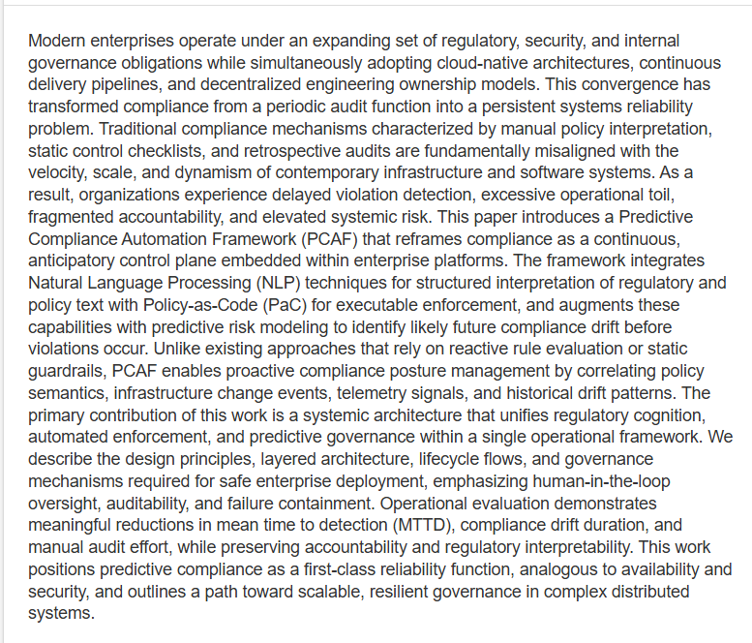
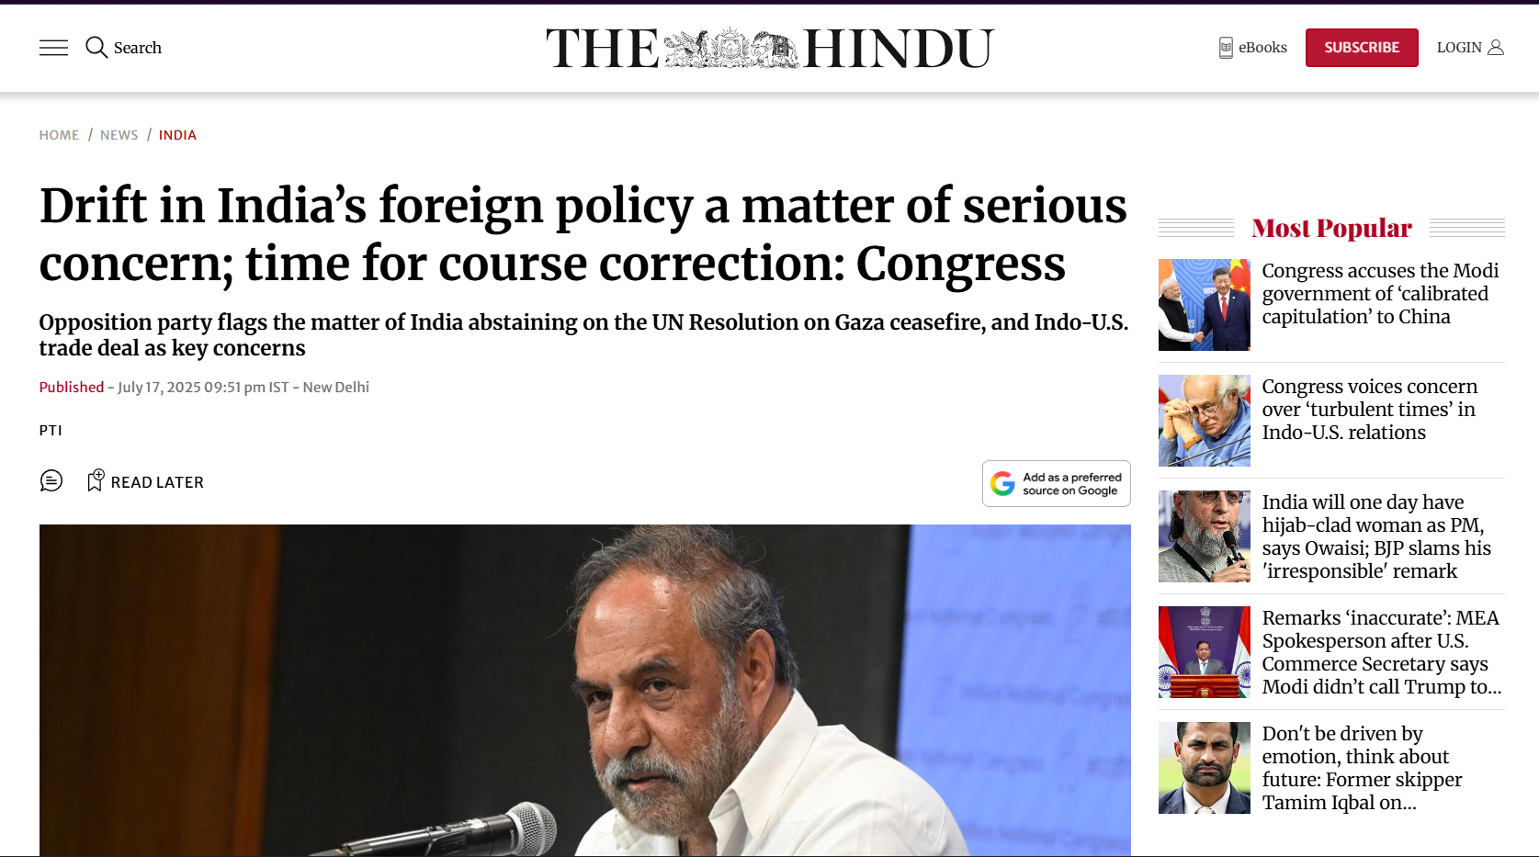
https://www.thehindu.com/news/national/drift-in-indias-foreign-policy-a-matter-of-serious-concern-time-for-course-correction-congress/article69824440.ece

https://docs.acceldata.io/documentation/schema-drift-policy

2. “Natural Language Processing for Policymaking”
A chapter discussing how NLP techniques such as text classification, topic modelling, event extraction, and text scaling can support evidence-based policymaking, interpretation of political decisions, policy communication, and policy effects analysis.
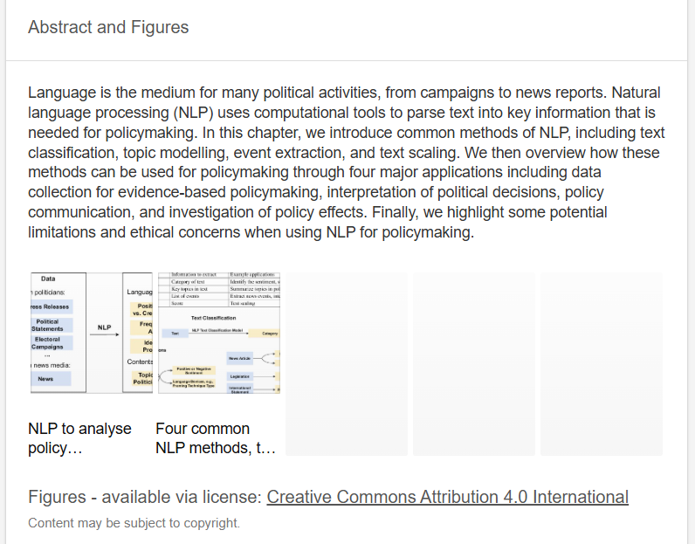
https://www.researchgate.net/publication/367352950_Natural_Language_Processing_for_Policymaking

